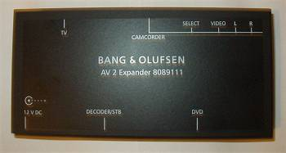 | 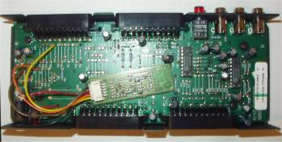
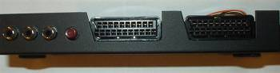 | 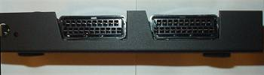

AV2 Expander (Part number 8089111)
Updated to be used with Beo4 and DVDs. Its inputs are as follows:
- TV - connection to the MX TV series of television
- DECODER/STB - for the digital box or decoder. Input/output socket
When no other equipment is connected, this socket is automatically selected. An STB controller has to be installed to be able to operate it with the Beo4.
- DVD - for the DVD1, input-only socket. To activate socket for other DVD's, it is necessary to press the DVD or CDV button on the Beo4 and then operate the non B&O DVD with its own remote
- CAMCORDER - SCART for camcorder, Video camera, etc. To activate this socket it is necessary to depress the red button on the AV2. The unit illuminates when activated. To access the socket on the MX, press V.TAPE2 on the Beo4. It is necessary to switch off the socket with the red button after use, otherwise you can't access the other sockets. This is an input-only socket
- VIDEO L R - RCA plugs with video signal and sound left and right. This socket is used to connect a non-B&O audio product and is also suitable for the connection of video games. This is the same socket as CAMCORDER, but with RCA plugs.
The AV2 Expander comes complete with instructions in English, German and French together with a 12V power supply.

